If private server want limited internet access then we need to use VPC endpoints.

Steps to create VPC endpoints:

1. Search VPC, then from left side select endpoint and then click Create endpoint.

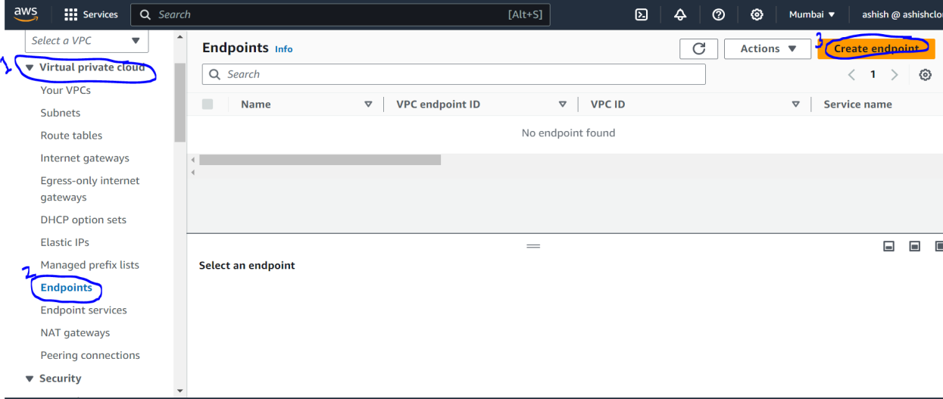

1. Then Goto **Endpoint settings, and in** Name tag *– optional enter endpoint name.*
2. Then In Service category select AWS service.

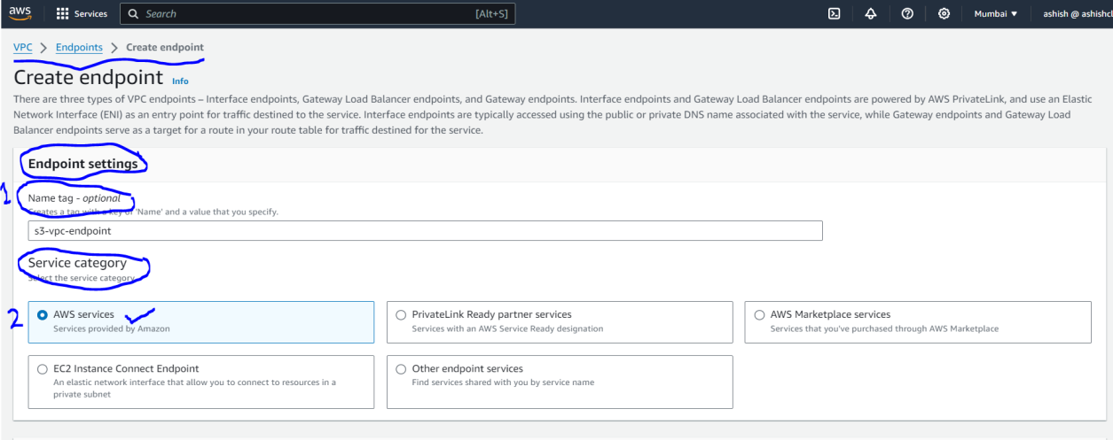

1. Then in **Services,** service aws service name for which you want to give access permission to private server and select **gateway** as **Type**.
2. Select VPC.

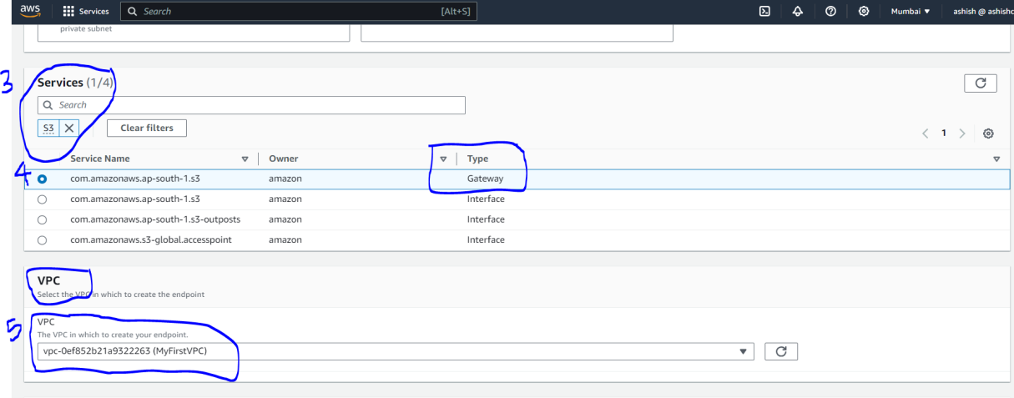

1. Then select **Route tables.**
2. Then **in Policy** select **Full access.**

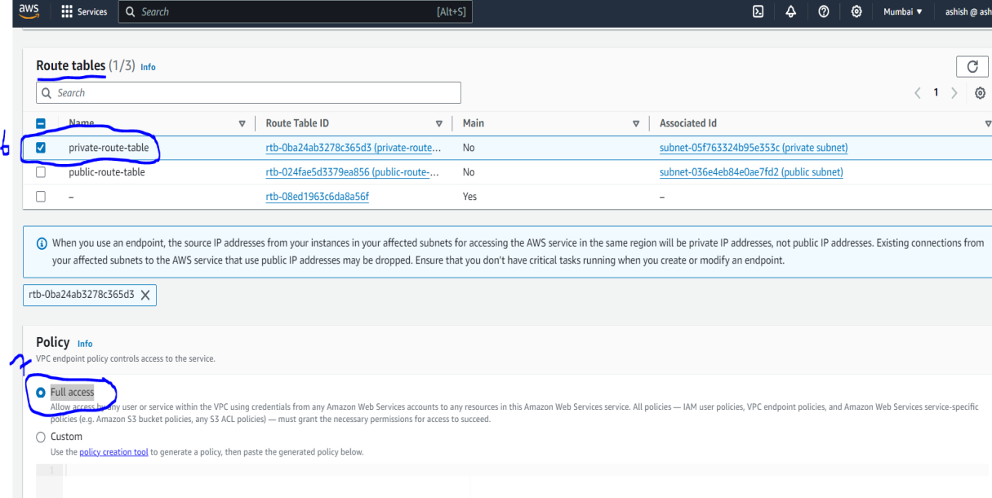

1. Then if you want to verify that endpoint got linked with route table or not, so for this goto **Managed prefix lists,** in this you will get one **Prefix list ID** got created**.**

